**Part 1: MySQL Backup and Recovery**

First is running the CMD as Administrator

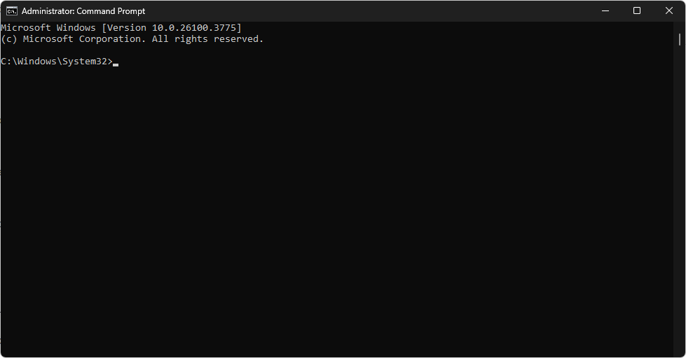

Then navigate to the path which is “C:\Program Files\MySQL\MySQL Server 9.2\bin”

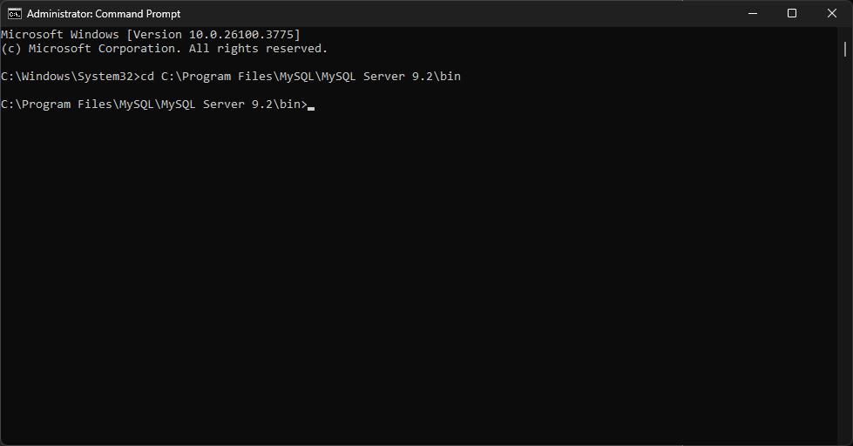

mysqldump -u root -p your_database_name > /path/to/destination/backup.sql

for example

mysqldump -u root -p library_ms > "C:\Users\akwean\Downloads\backup.sql”

Simulate dropping database

First is go to the mysql -u root -p to open the MySQL Command Line Client

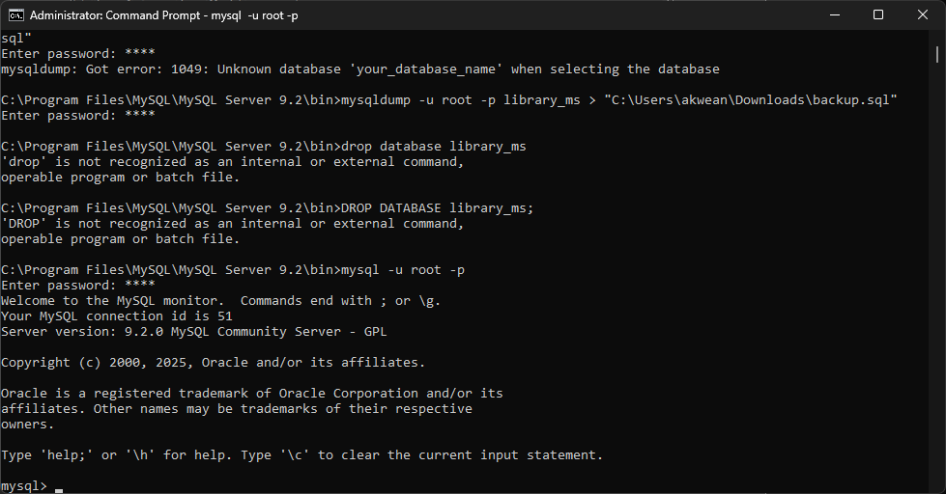

Then drop the table

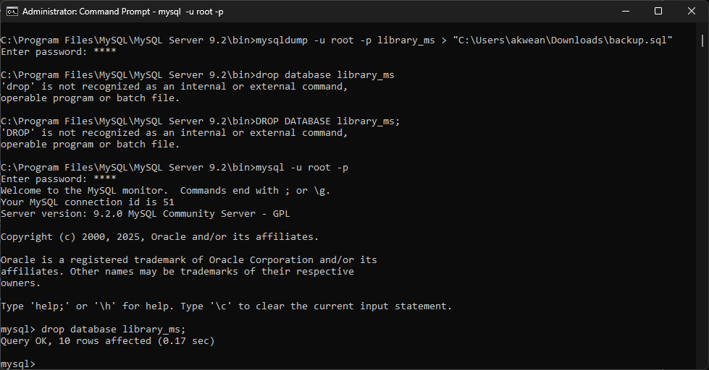

Next is create the database again:

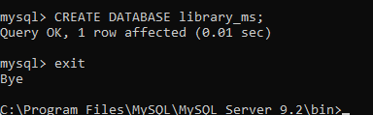

Then type Exit to exit the MySQL Command Line Client

Next is restore it using mysql -u root -p library_ms < "C:\Users\akwean\Downloads\backup.sql”



**Part 2: Cloud Deployment**

I choose to use railway so sign up and created the **MySQL** from the service templates.

Then us the public network to connect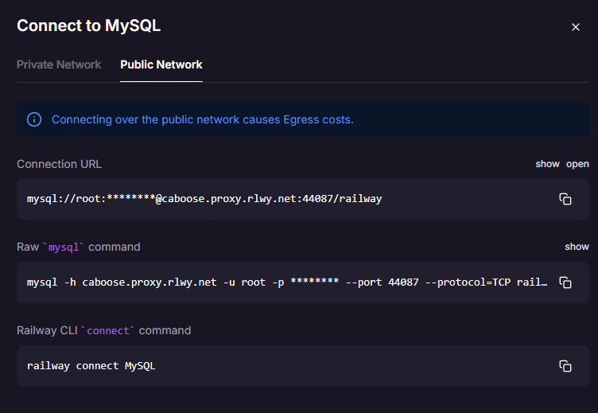

Then I uploaded it using

mysql -h caboose.proxy.rlwy.net -u root -pqTwPuQDooeAjByuugZhksEHgZWIXRrNA --port 30615 --protocol=TCP railway < "C:\Users\akwean\Downloads\backup.sql”



But it got the message the it said members is full means it has reach the free tier capacity.

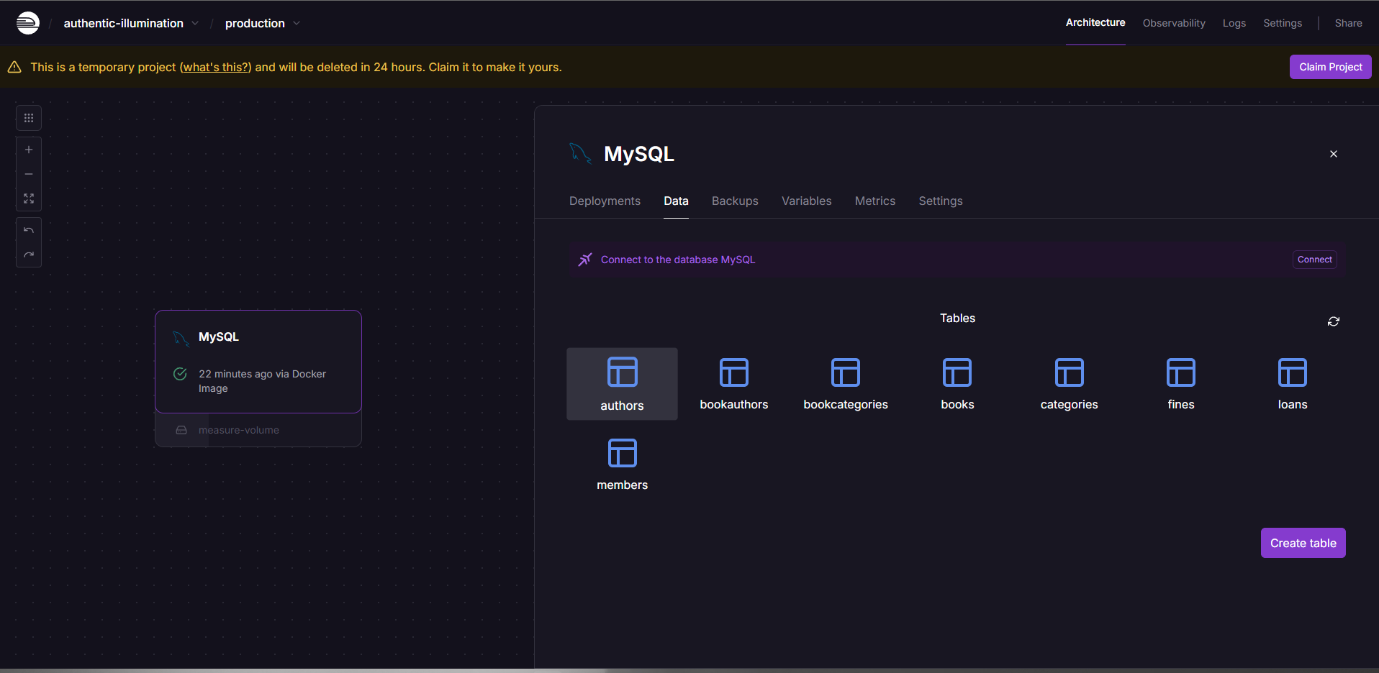

So I check the Mysql cli of the Railway

This the results

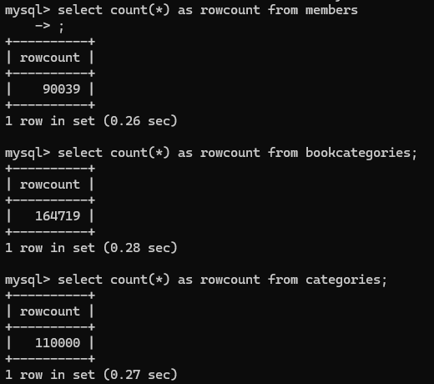

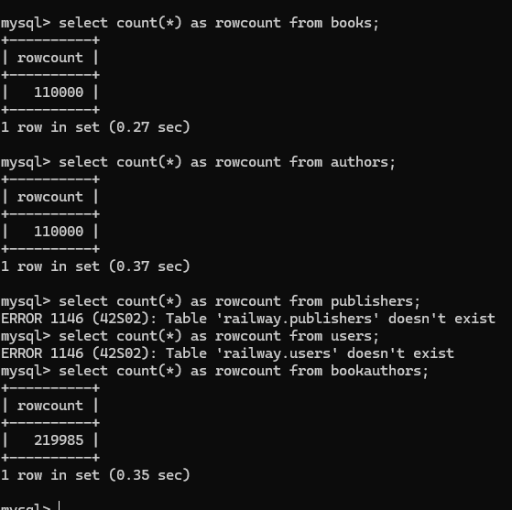

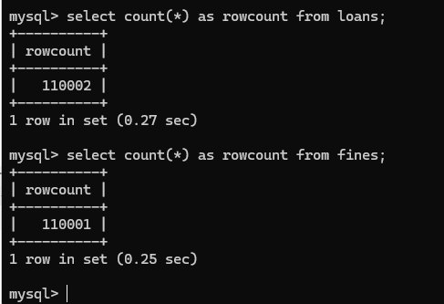

So three tables (Publishers, Users, BookAuthors) even the Members table only got 90k of it rows were not uploaded because of the 0.512 gb storage limit of the Railway.

At last I was able to connect it to the work bench

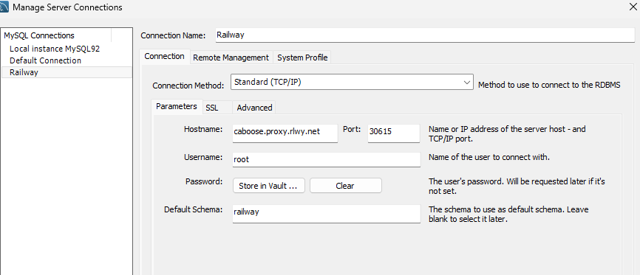

This is the railway connection

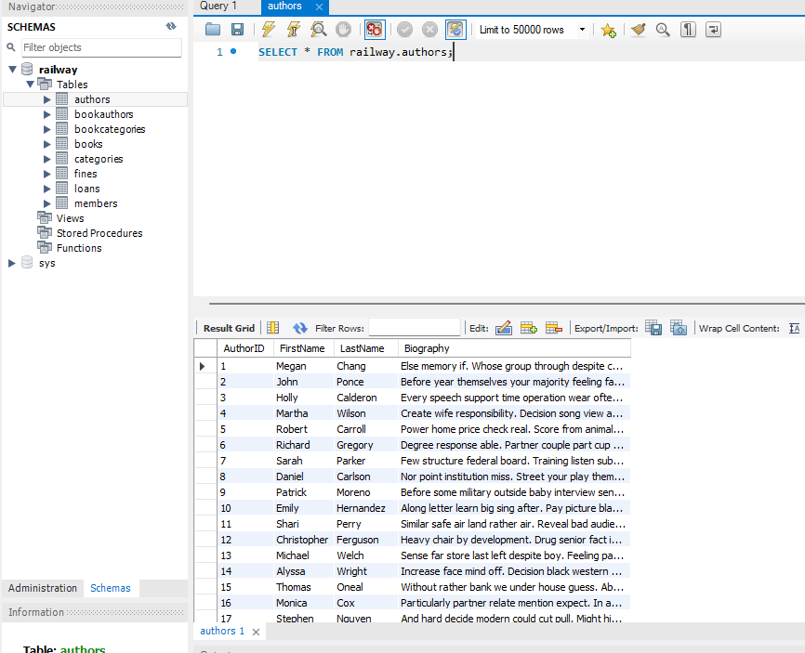

There except the problems missing tables because the free tier only has 512mb it is working fine

This is the in my local sql connection

